A000-US-IL-Cahokia-Pipe-Bear-Dodge Collection, 1845-c 900-1200

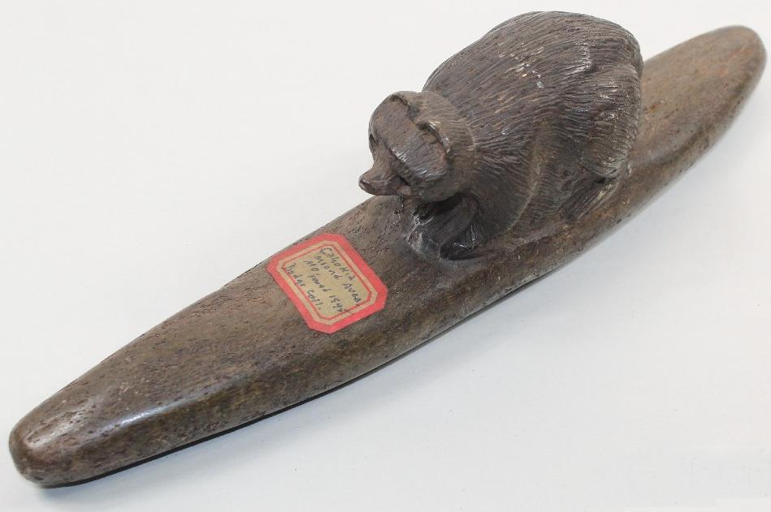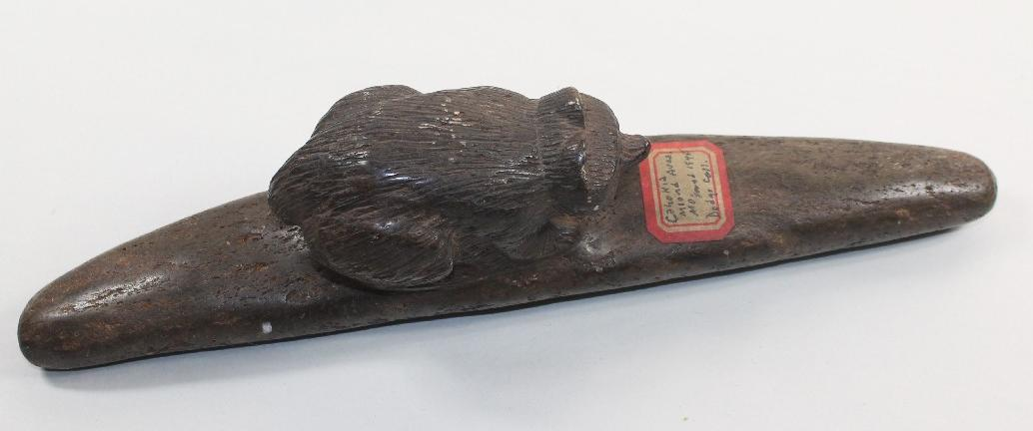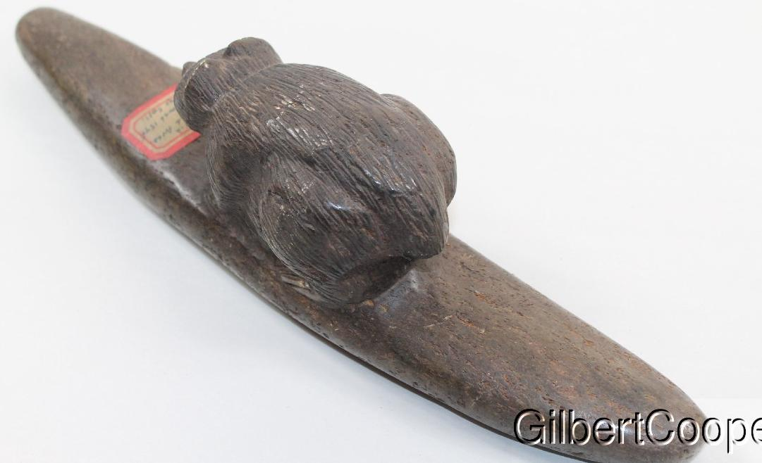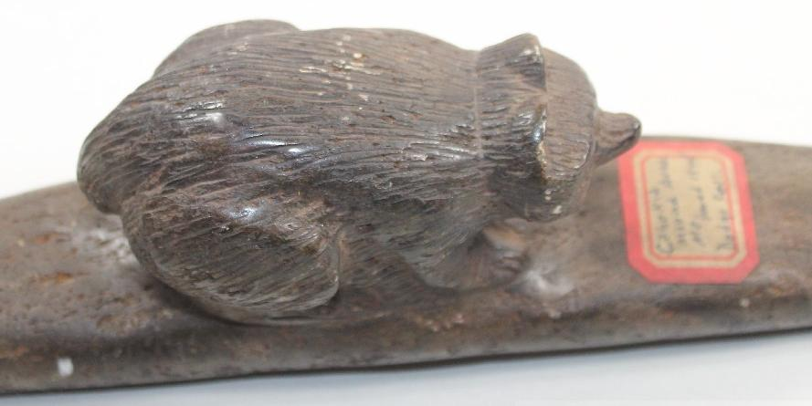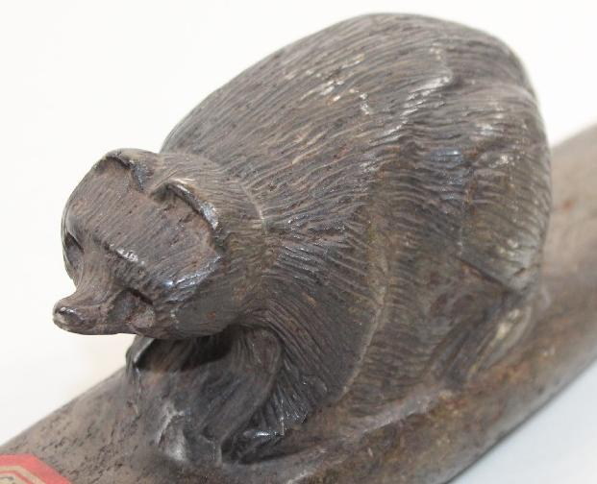

Figs.1-5. US-IL-Cahokia-Pipe-Bear-Dodge Collection, 1845-c 900-1200

Large Bear Effigy Pipe Preform. There is an old sticker that reads “Cahokia Area, 1845, Dodge Collection.”

**Case no.: 11**

**Accession Number:**

**Formal Label:** US-IL-Cahokia-Pipe-Bear-Dodge Collection, 1845-c 900-1200

**Display Description:**

Large Bear Effigy Pipe Preform. There is an old sticker that reads “Cahokia Area, 1845, Dodge Collection.”

**LC Classification:**

**Date or Time Horizon:**

**Geographical Area:**

**Map:**

**GPS coordinates:**

**Cultural Affiliation:**

**Media:** **Dimensions:**

**Weight:**

**Condition:**

**Provenance:**

This Bear Effigy Pipe was probably collected by Thomas M. Easterly (1809-1882), a native of Vermont, who was an itinerant calligrapher and teacher of writing in Albany, New York. It was there that he learned the daguerreotype process in 1843. In 1844 he decided to take this process West, and so he left for New Orleans, traveled up the Mississippi to St. Louis where he established a daguerreotype studio.

The extant collection of 636 of Easterly’s daguerreotypes contains portraits of Keokuk, Sauk and Fox chiefs made in 1847 and Ioway chiefs made in 1849, and is notable for the unusual number of landscape views of Cahokia and the now destroyed "Big Mound" in St. Louis. It was probably during this period that this Bear Effigy Pipe was acquired by Easterly. This pipe and the daguerreotypes from Easterly’s collection became known as the Dodge Collection after Margaret Wing Dodge, a descendant of Mrs. Easterly’s sister who inherited them. At this time, this pipe came by way of Gilbert Cooper. Then, when the rest of the collection was given to the Missouri Historical Association by Mrs. Dodge, the collection became known as the Easterly-Dodge Collection.

**Discussion:**

**References:**